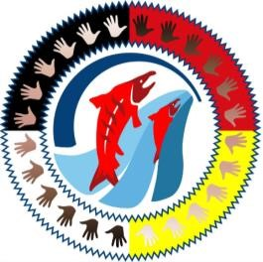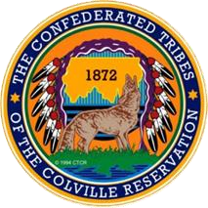

Coulee Medical Center, the Board of Commissioners

in partnership with the

Colville Tribal Health Program

Proudly Present:

5th Gathering of Wellness Powwow

9/19/2024

Powwow Etiquette

1. Listen to the Master of Ceremonies (MC). He will announce who is to dance and when. He will also let you know when taking pictures or video record is inappropriate. He will also ask you to stand for certain songs such as during Grand Entry and Honor Songs.
2. The Flag Song, or Indian National Anthem, is sung when the American Flag is raised or lowered during Grand Entry and the Grand Exit. Please stand and remove hats during the singing of this song.
3. If taking pictures, ask the dancer first. Please be courteous and ask permission.
4. Please respect the traditions of the American Indian culture.

Certain items of religious significance such as eagle feathers should be worn only by those qualified to do so. Please respect personal space and do not touch dancers.

1. No alcohol or drugs are allowed at powwows. If you smoke tobacco, please use the designated smoking area. Please smoke responsibly.
2. Spectators and visitors are welcome to join in and dance during Intertribal songs and other social dances such as the owl dance and round dance are songs that. Please feel free to come out to the dance floor and dance during these songs.
3. If at any time you are uncertain of procedure or etiquette, please check with the MC or the powwow event staff. They will be glad to help you with your questions.